**SECTION A**

**Attempt** any three **questions**

1. State what is meant by the term boiling point constant of a substance. (01 mark)
2. Describe an experiment that can be used to determine the molecular mass of a compound using the method of elevation of boiling point.[Diagram not required] (07 marks)
3. Explain why the method you have described in (b) above is not suitable for determining the molecular mass of:
4. Starch in aqueous solution. (02 marks)
5. Aluminium chloride dissolved in benzene. (02 marks)
6. The osmotic pressure of various concentrations of solute X in methylbenzene at room temperature are given below.

|  |  |  |  |  |  |  |
| --- | --- | --- | --- | --- | --- | --- |
| Concentration (g/dm3) | 1.0 | 2.0 | 3.0 | 4.0 | 5.0 | 6.0 |
| Osmotic pressure (N/m2) | 23 | 37 | 53 | 75 | 92 | 109 |

1. Plot a graph of osmotic pressure against concentration. (03 marks)
2. Use the graph in (d) (i) above to determine the molecular mass of X. [Universal gas constant, R = 8.314J/K/mol] (04 marks)
3. Manganese is one of the transition elements.
4. State: (03½ marks)
5. Describe the reactions of manganese with each of the following substances.
6. Oxygen gas. (02 marks)
7. Dilute sulphuric acid. (02 marks)
8. Concentrated sulphuric acid. (02 marks)

[Your answer should include relevant equations for the reactions]

1. State what would be observed and write equations for the reactions that would take place when aqueous manganese (II) chloride is added.
2. Dilute ammonia solution drop wise until in excess and mixture allowed to stand. (04 marks)
3. Concentrated nitric acid followed by little solid bismuthate (V). (03 marks)
4. Potassium manganate (VII) is commonly used in volumetric analysis even when it’s not a primary standard.
5. Two reasons why potassium manganate (VII) is commonly used in volumetric analysis. (01 mark)
6. One reason why potassium manganate (VII) is not a primary standard. (01 mark)
7. Name one substance that can be used to standard potassium manganate (VII). (01 mark)
8. Write equation for the reaction between acidified potassium manganate (VII) and hydrogen peroxide. (01½ marks)
9. An organic compound, Q with a molecular mass of 106 contains 79.25% carbon, 5.66% hydrogen and the rest being oxygen.
10. Determine the:
11. Empirical formula of an organic compound, Q. (03 marks)
12. Molecular formula of an organic compound, Q. (01 mark)
13. Compound, Q burns with a sooty flame and forms a yellow precipitate with 2,4-dintrophenylhydrazine.Write the name and structural formula of an organic compound, Q. (02 marks)
14. Write equation for the reaction between an organic compound, Q and 2,4-dintrophenylhydrazine under acidic condition and outline a mechanism for the reaction. (05 marks)
15. Using equations only, show how an organic compound, Q can be:
16. Obtained from 1,2-dibromoethane. (04 marks)
17. Converted to nitrobenzene. (03 marks)
18. Converted to benzoyl chloride. (03 marks)
19. (a) State what is meant by the following terms: (@01 mark)
20. Lattice energy.
21. Heat of combustion.
22. Describe an experiment that can be used to determine the enthalpy of combustion of graphite by a method of Bombo calorimeter. [Diagram is not required] (05 marks)
23. When 30g of graphite was burnt completely in oxygen gas, the heat liberated raised the temperature of 2.35kg of water from 24.5ᵒC to 67.5ᵒC. Calculate the molar heat of combustions of graphite. [𝝆H2O = 1g/cm3, SHC of water = 4.2J/g/K]
24. Explain why the value of the molar heat of combustion of graphite is than that of theoretical value. (01 marks)
25. Some thermochemical data of copper, copper (II) chloride and chlorine are given below.

|  |  |
| --- | --- |
| Process | Enthalpy change [kJ/mol] |
| Enthalpy of formation of copper (II) chloride | -220.0 |
| Enthalpy of sublimation of copper | +338.3 |
| First ionization energy of copper | +745.0 |
| Second ionization energy of copper | +1,958 |
| First electron affinity of chlorine | -364.0 |
| Bond dissociation energy of chlorine | +121.1 |

1. Use the values above to draw an energy level diagram which can be used to determine the lattice energy of copper (II) chloride. (04 marks)
2. The hydration energy of copper (II) chloride is -2,883.9k/J/mol. determine the enthalpy of solution of copper (II) chloride. (02 marks)
3. Comment on the effect of temperature on the solubility of copper (II) chloride. (01 mark

**SECTION b**

**Attempt** only two **questions in this section.**

1. State:
2. Partition law. (01 mark)
3. Three conditions under which the law is valid. (01½ marks)
4. Describe an experiment that can be carried be out to determine the distribution coefficient of butanoic acid between water and butan-1-ol. (07 marks)
5. When 100cm3 of aqueous solution containing 30g of ethanoic acid was shaken with 50cm3 of butan-1-ol, 12g of ethanoic acid between water and butan-1-ol. (03 marks)
6. The aqueous solution of ethanoic acid in (c) was shaken twice with 25cm3 of portions of butan-1-ol. Calculate the mass of ethanoic acid extracted. (06 marks)
7. State one other applications of the distribution law. (01 mark)
8. Describe how nitric acid is manufactured starting from ammonia. (07 marks)

[Your answers should include relevant equations for the reactions take place]

1. State:
2. 1.13g of sample of a fertilizer containing nitrogen nitrogen was boiled with excess sodium hydroxide solution to produce ammonia. The ammonia produced required 25.0cm3 of a 0.2M sulphuric acid for complete reaction. Calculate the percentage mass of ammonia in the compound. (04 marks)
3. Briefly describe how anion in nitric acid can be confirmed in the laboratory. (02 marks)
4. State two industrial uses of nitric acid. (01 mark)
5. Write equations to show how the following compounds can be synthesized.
6. Phenol from benzene and propene (02½ marks)
7. Phenylamine [aniline] from phenol (03 marks)
8. Propanoic acid from ethene (02½ marks)
9. But-2-yne from propene (03 marks)
10. Propanone from ethanol (03 marks)
11. Benzaldehyde hydrazine from benzene (03 marks)
12. Sodium benzenesulpahonate from ethyne (02½ marks)
13. Explain the following observations.
14. The boiling point of ethanoic acid is 118ᵒC, wherea methylmethanoate with the same formula mass boils at a temeperature of 32ᵒC. (03 marks)
15. Lead (II) chloride is more soluble in concentrated hydrochloric acid than in dilute hydrochloric acid. (05 marks)
16. When chlorine is bubbled in to dilute aqueous sodium hydroxide, a pale yellow solution is formed. The solution turns colourless on heating at a temperature of 75ᵒC. (04 marks)
17. Methanoic acid forms a grey precipitate when boiled with ammoniacal silver nitrate solution whereas ethanoic acid does not. (03 marks)
18. A mixture of benzene [b.pt 80.1ᵒC & water [b.pt 100ᵒC] boils at a temperature less than the boiling point of benzene. (05 marks)

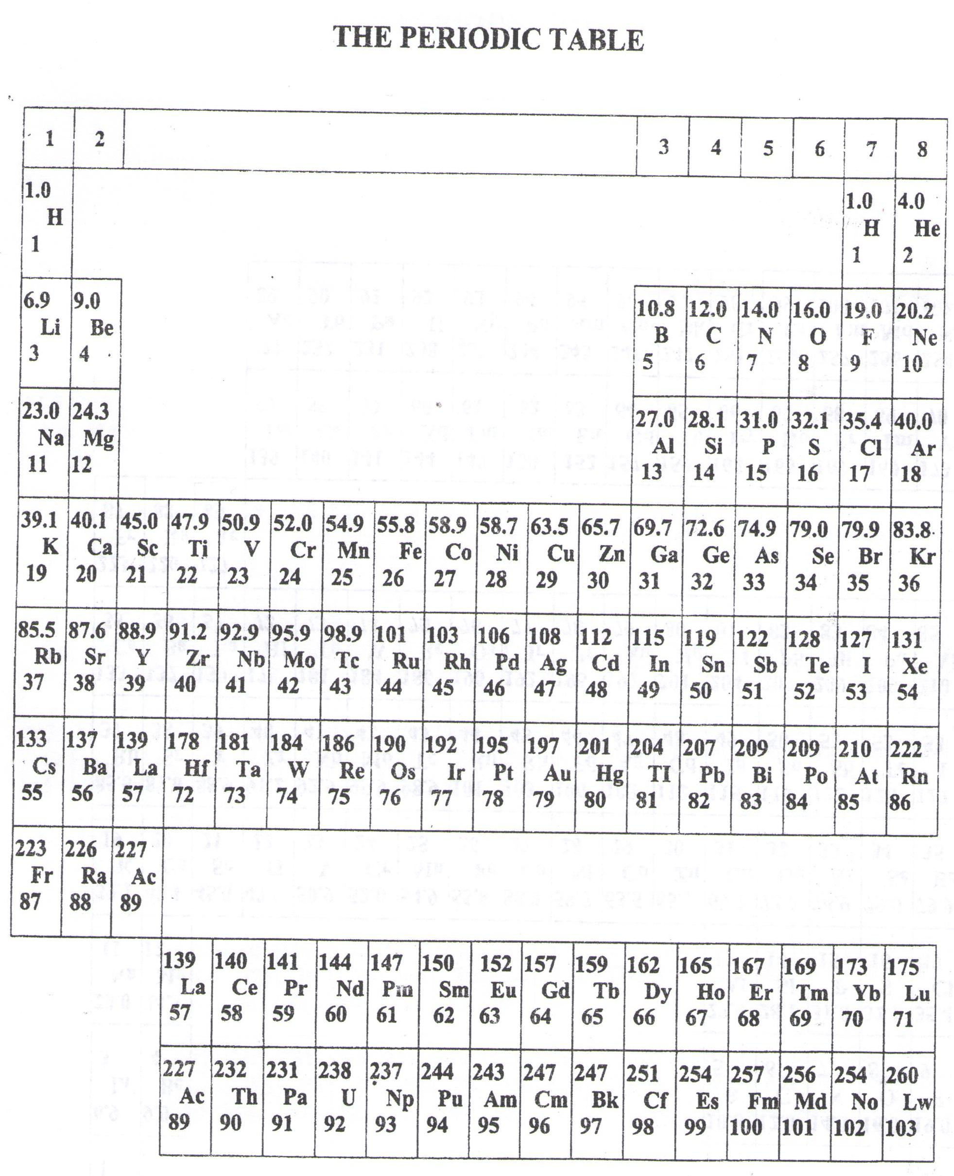

* ===END===

WELCOME TO SENIOR SIX, YEAR 2023

This is the last page of the printed paper, Page 06